Amory Railroad Festival
Main Street & Frisco Park
P.O. Box 131
Amory, MS 38821
Specialty Food Vendors

General Guidelines for the Amory Railroad Festival
The Amory Railroad Festival is being held April 13-16, 2023, on Main Street in Amory, with entertainment being held in Frisco Park.

- ENTRY TO FESTIVAL
  - Vendors are permitted by invitation only.
  - Applications are received and reviewed by the Committee
    - Pictures will be required of product and booth set up.
  - All vendors will be assigned booths based on type of food being sold.
  - The Fee is $800 for each 30’ space. Electricity is included in that price.
    - If you have a trailer, please take into consideration your complete length, including the hitch.
  - ALL BOOTHS WILL BE REQUIRED TO PAY A $200.00 CASH-ONLY DEPOSIT WHEN ARRIVING AT THE FESTIVAL. THIS IS FOR CLEANUP. YOUR BOOTH WILL BE CHECKED BY A MEMBER OF THE COMMITTEE AT CHECKOUT, IF YOU HAVE CLEANED UP YOUR AREA AND TURN IN YOUR TAX FORM, THEN YOU WILL BE GIVEN YOUR $200 CASH BACK

- PROCEDURE OF SHOW
  - Vendors are required to be present in order to sell their own merchandise
  - ALL VENDORS are REQUIRED to be set up for all three days (Friday 9-6, Saturday 9-6, and Sunday 12-4); this is the minimum time, most vendors choose to open earlier and stay later.
  - The Railroad Festival Committee will juror all exhibits during show time.
  - SALES TAX WILL BE COLLECTED FROM EVERY VENDOR, AT THE SHOW….NO EXCEPTIONS!!

- ACCEPTANCE OF FESTIVAL
  - Each vendor will be allowed to bring only the types of items listed on their applications. Additional items must be approved by the committee
  - You will be required to keep all merchandise within your booth space.
  - You will automatically be issued an invitation for each Festival once accepted unless otherwise notified.
  - All Vendors must take their own provisions for shade or rain. If you use a tent, you will need to provide a way to secure that tent. NO STAKES!!!!
  - If you do not respond to the invitation to our Festival, whether accepting or declining, you will not receive an invitation to the following Show.
  - If you decline two consecutive Festivals, you will not be issued an invitation to the following Festival.
  - Vendors are not allowed to transfer their invitations.
  - No REFUNDS

- FOOD GUIDELINES
  - Your menu is only to be the items that are requested on application and approved by the festival committee.
  - You MUST have a Safe-Serve Certification for at least one person in your group.

PLEASE NOTE: We have a very large festival. These guidelines have been developed in the best interest of our vendors and the buying public. These are for your protection and ours to maintain a quality Festival.
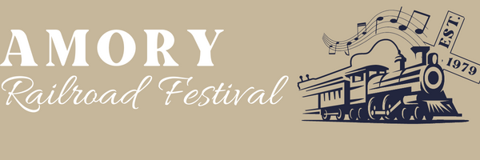
Amory Railroad Festival
Main Street & Frisco Park
P.O. Box 131
Amory, MS 38821

Application for Food Court Vendor

Name:_____________________________________________________________________
Telephone: Home_______________ Work_________________ Cell____________________
Company or Professional Name _________________________________________________
Mailing Address ______________________________________________________________
E-Mail______________________________________________________________________
City_____________________________ State______________ Zip _____________________
PHOTOGRAPHS OF YOUR FOOD BOOTH!!
Please include your check with this application. If an invitation is not extended, your check will be returned. Makes checks payable to Amory Railroad Festival $800.00 plus $200 cash deposit (deposit paid at check-in and will be returned upon checkout when you area is checked for cleanliness and tax form submitted).
List menu items, include price range.
_________________________________________________________________________________________________________________________________________________________________________________________________________________________________________________________________________________________________________________________________________________________________________________________________________________________________________
I DECLARE THAT ALL OF THE ITEMS I BRING TO THE AMORY RAILROAD FESTIVAL ARE ONLY ITEMS LISTED IN THIS APPLICATION AND IF EXTENDED AN INVITATION BY THE COMMITTEE, I AGREE TO COMPLY WITH THE RULES OF THE FESTIVAL.
________________________
SIGNATURE

